Keep our Sand and Sea Plastic Free

Working towards eradicating single use plastic through education and tourism in the resorts of Ayia Napa and Protaras, Cyprus

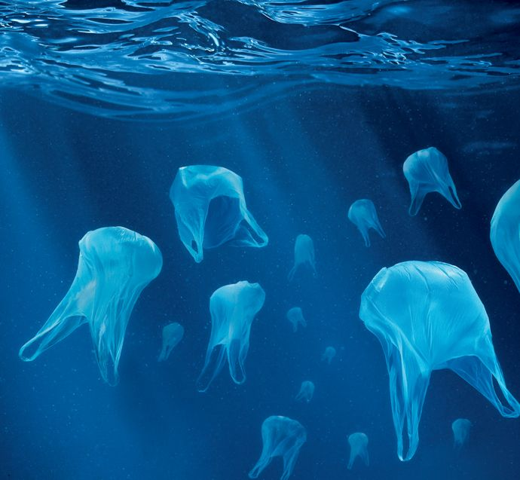

Hotel Training Toolkit

Background
Plastics make up 95% of sea and beach waste across the Mediterranean, and the Mediterranean Sea has one of the highest levels of plastic pollution in the world, exacerbated by water circulation patterns trapping floating plastic. Around 80% of rubbish collected on Cyprus beaches is made of plastic.
The UN Environment places ocean plastics among the 6 most serious environmental emergencies, and it is a focus area of SDG14 “Life below water.” Significant efforts are needed to avoid the oceans containing 1 tonne of plastic for every 3 tonnes of fish by 2025 and, by 2050, there being more plastics in the ocean than fish (by weight).
To address this issue, behaviour change among business and residential populations is essential. For many Mediterranean countries, this means working with the tourism sector, a significant contributor to plastics pollution: it is estimated that the 200+ million tourists visiting the Med each summer generate a 40% increase in marine litter.
Cyprus receives over 3.5 million tourists annually (3 times the resident population). It is also the second highest producer of municipal waste in the EU, of which only 16% is recycled (compared to an EU average of 46%). Although efforts are being made by the Cyprus government to address the issue (including the recent introduction of a charge on plastic bags), there remains a serious need to raise awareness across all stakeholder groups and encourage collective action.

Around the world, one million plastic drinking bottles are purchased every minute, while up to 5 trillion single-use plastic bags are used worldwide every year

The Project
As sand and sea are among Cyprus’s most precious assets, this project aims to protect both by working towards the eradication of single-use plastic.
The project will focus on reducing the amount of single-use plastic waste generated and discarded in resorts, on the beaches and in the ocean, as well as promoting recycling. It will raise awareness of the issue with residents, youths and tourists in order to reduce demand, and work with tourism businesses to change procurement practices.
The aim of the project is to bring together all stakeholders (tourists, tourism businesses and residents) across the resorts to engage with the issue and deliver collective action that will reduce the amount of single-use plastic entering the waste stream – and ultimately the marine environment.

Single Use Plastic Reduction in Hotels
Great for the environment and good for business
Whilst reducing the amount of plastic waste has environmental benefits, it also creates cost savings for the hotel, as well as positive feedback from guests.
A plastic reduction project with hotels in Cyprus in 2012 demonstrated that making changes to plastic use can influence customers’ perceptions of the businesses in a positive way. Guests perceived the hotel’s efforts to reduce plastic as a sign of their commitment to caring for the environment.

Direct cost savings can be achieved through the reduction in plastic bottles, cups, and packaging. Additionally, indirect savings can be made through reduced staff time on ordering and handling stock and clearing used disposable plastic items from bar, restaurant and pool areas.
Reducing the use of plastic and raising staff and guest awareness will significantly benefit the environment including less litter on the beaches, thereby increasing the attractiveness of the resort. Landfill sites will fill up less quickly.
Climate change is everyone’s business
Longer term, the hotel will reduce its indirect contributions to climate change through the energy and transportation required to use and dispose of plastic. Compliance will also mean that hotels will be ready when EU rules on single-use plastics comes into force in 2021.

Engaging your staff
Training your staff to understand the important role they can play in reducing plastic use will encourage them to commit to new ways of working.

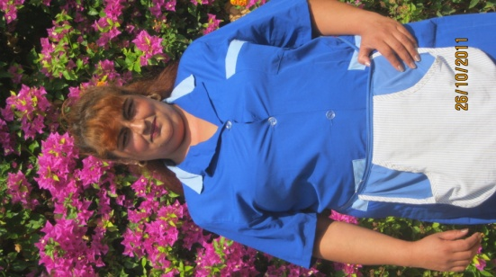
“I have changed the way I work. I now empty the plastic bags into large rubbish bins rather than changing them each time. I feel positive about this project and I’m pleased I am doing something good for the environment. I have children and grandchildren. We have to do something good for future generations.”

Sonia Archikova, Cleaner
Ascos Coral Beach Hotel

It’s all about simple and practical solutions

Using this Toolkit

This toolkit will help hotels to reduce the amount of single-use plastic waste created by hotel operations. You can use the toolkit as it is or adapt for your own organisation.

Getting Started
The best option from an environmental and financial standpoint is to avoid/minimise waste wherever possible.

In most cases waste minimisation measures are simple, inexpensive and highly cost effective.

Waste minimisation can reduce waste generation in hotels by more than 50%

The first question to ask is “Do we really need this?”
If you cannot operate without these single use items, then commit to choosing the alternative that’s affordable and appropriate and has the smallest environmental footprint.

10 simple single-use plastic reduction guidelines
- Replace one-use plastic cups with multi-use durable cups around the pool area
- Replace bottled water with drinking water dispensers served in durable cups
- Stop the use of bin liners in the bedrooms and use in bathrooms only - change only when soiled
- Train hotel employees to use the correct size and thickness of plastic liners
- Consider alternative options to wrapping glasses in plastic in bathrooms
- Discontinue the wrapping of fruit baskets with plastic
- Use refillable dispensers rather than individual packaging for soap and shampoos
- Eliminate straws or provide only when requested by hotel guests
- Purchase cleaning materials in bulk
- Collect garden waste in reusable bags instead of plastic liners

Case Studies

Disposable cups – Case study
200-room, all-inclusive European hotel
- Use of disposable cups = 800000 cups/year = 4/guest/day
- Cost of disposable cups = € 24.000 /year
- Savings achieved with durable cups = € 16,000 /year

Bottled water – Case study
500-room, all-inclusive hotel
- Hotel bottled water consumption = 210.000 L/year
- Expenditure for 1,5L disp. bottles = € 27.500 /year
Switching to 19L returnable jugs would:
- Reduce bottled water costs by €15000 per year
- Prevent discarding 140000 plastic bottles per year

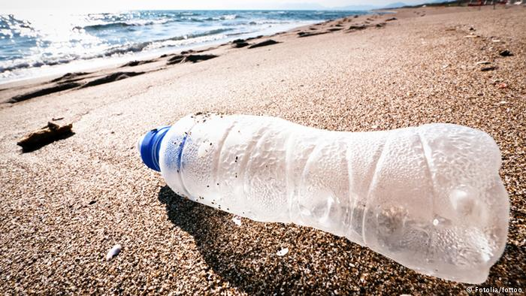

Communicating with Staff

Train your staff in each department to follow the practical guidelines provided in this toolkit and in the accompanying PowerPoint presentation.
- Housekeeping and Laundry
- Food & Beverage
- Outdoor maintenance
Housekeeping and Laundry
Guest Rooms
- Where possible, use guestroom rubbish bins that don’t need disposable plastic liners
    - Only use liners in bathroom bins and change only when soiled
    - Ask guests to put messy waste in these bins
    - Use compostable bags
    - Room bins can just be wiped over
- Consider alternative options to wrapping glasses in plastic - if glasses are upturned, they should not need plastic wrapping.
- Use a minimum-waste format for fruit baskets (just put fruit in a bowl)
- Avoid excessively packaged amenities e.g. shower cap wrapped in plastic in a cardboard box
- Use refillable dispensers rather than individually packaged amenities or provide amenities on request only
- Provide drinking water in alternative to plastic bottles
    - Glass bottle or carafe
    - Water dispenser or refill station close to room

Given that many guests bring their own preferred shampoos, conditioners and shower gels with them on holiday, some hotels have been experimenting with not providing amenities in hotel rooms but offering to supply on request. They have explained clearly that the reason for doing this is because they are trying to reduce single use plastic and the reasons why. Most hotels who have tried this have reported minimal uptake and sometimes none at all! Guests can be conditioned into expectations of zero single-use plastic if supported by good communications.

Laundry and Cleaning
  - Return guest laundry by providing an alternative method e.g. a basket
  - Avoid using plastic bags to transport and collect guestroom linens – instead use trolleys or canvas bags
  - Cleaning products
  - Purchase concentrated product in bulk
  - Dilute properly and transfer to refillable dispensers
  - Required dilution rates are typically very high (typically 1:50 to 1:200) – ensure that laundry staff respect dilution ratios
  - Always follow manufacturer’s recommendations

Food & Beverage
- Avoid food items in single-portion packaging
- Use open jars/bowls and pre-portioned without plastic e.g. butter in a small dish
- Use sauce dispensers or bottles
- Buy beverages packaged in refillable containers (not individually wrapped)
- Provide straws only when requested from hotel guests (and find alternatives to single-use plastic straws e.g. bamboo, paper etc.)
- Avoid wasteful F&B presentations
- Encourage suppliers to provide their goods in returnable crates, containers, pallets
- Avoid purchasing disposable items, replace one-use plastic cups with multi-use durable cups for use around pool area
- Provide reusable cutlery (metal) and porcelain/china crockery
- In the pool areas provide reusable hard plastic plates and crockery or single use compostable/biodegradable and cutlery (wooden/bamboo/corn)
- Provide water in glass bottles/carafes and provide glasses
- Place food in baskets/trays
- Use paper bags for packed lunches

Outdoor maintenance
- To collect garden waste use reusable bags
- Where possible, use rubbish bins that don’t need plastic liners
- Ensure that rubbish and recycling bins don’t overflow and cause rubbish to flow onto beaches

Communicating with Customers

Our industry is providing us with many examples of successful elimination of single-use plastic, and with specific messaging to both team members and guests you can transition away from single-use without impact to your operation or your guests’ expectations. In fact, trends now show that guests do not expect hotels to be using such products in a fragile environment and will applaud rather than be critical of your choice not to use such items.
Here are some ideas for how you can communicate with your guests: -
- Adapt the letter template and customer survey provided in this toolkit to explain your commitment to your customers and to gain insight into their views on your efforts
- Look at areas of the hotel where you can put notices for guests so that they can help you to reduce plastic waste
- Provide reusable shopping bags in the reception area/hotel rooms
- Involve your guests, make them feel they can play their part towards the environment by showing them the progress you are making with their help.
- Through the kids’ clubs find fun ways to raise awareness
- By making the message personal and meaningful rather than generic, telling people why your hotel is taking this route, promoting the positive difference it can make and explaining how guests can support it, you can take customers along on the journey with you

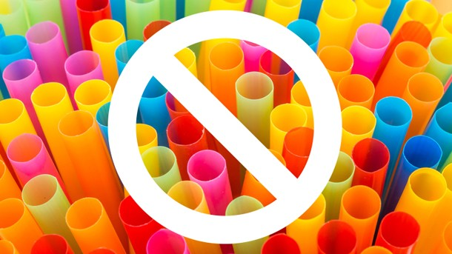

You can use the template below to communicate with guests by printing this letter to put with the information in guest rooms or on screen. You may need to adapt it depending on the actions you are taking to reduce single-use plastic.
Dear Guest
Keep our sand and sea plastic free
We are taking part in the ‘Keep our sand and sea plastic free’ project to reduce single-use plastic waste along with everyone else in the resorts of Ayia Napa and Protaras and we would really appreciate it if you could help us.
Most of the waste in Cyprus currently goes to landfill and plastic never degrades. Tourism contributes towards much of this waste, so we have a responsibility to help reduce this.
Here are some of the ways you can help whilst on your holiday: -
- Think twice before using plastic straws.
- Thousands of plastic cups are used by the hotel each season in the swimming pool area.
  - Please can you think about your use of plastic cups?
  - Make sure you don’t accidentally take 2 or 3 at once
  - Can you refill your plastic cup more than once?
- Bin liners are only provided in your bathroom bin in your room so if you have anything messy please dispose of this in the bin in your bathroom.
- If you go shopping whilst on holiday it would be great if you could keep using the same plastic bag rather than getting new ones every time you shop [or even better take a reusable cloth bag- we have some in reception)
- Cyprus is a hot country and it is important that you keep hydrated but please save as many plastic bottles as you can. The hotel can provide water on tap from the bar/has water dispensers, and you can refill your glass or reusable cups here.
- If you are using the toiletries supplied by the hotel, please make sure you use the whole container before disposing of it
- If you can see more ways in which the hotel can save plastic please let the staff on reception know so they can pass this on to the manager

By taking part you will be making a huge difference in reducing plastic waste in Cyprus.
Together we are caring for the places you love to visit, so that resorts like this one can still be enjoyed by future generations of visitors.
Thank you so much for helping us to keep our sand and sea plastic free.

Communicating with suppliers

Engaging your suppliers can help cut down on plastic waste. Here are some tips on how
- Encourage suppliers to provide their goods in returnable crates, containers, pallets
- Buy in bulk as much as you can
- Ask suppliers to source alternatives to single-use plastic
- Include alternatives to single use-plastic in tender specifications and contracts
- Talking to your suppliers about the plastic waste issues may help you to come up with some solutions that work for both of you

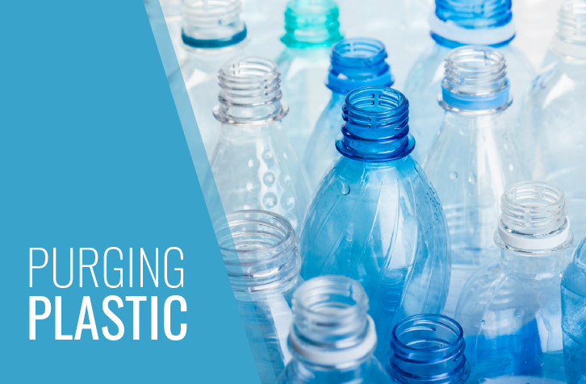

Monitoring Single-use plastic reduction

We want to demonstrate that Ayia Napa and Protaras are leading the way when it comes to reducing single-use plastic in tourism resorts. To do this it will be important to collect the data to show how much plastic has been prevented from entering the waste stream. The easiest way to do this is through examination of your purchasing records and stocktaking.

- Before taking any actions collate volume and cost of single-use plastic items in the same period of the previous year (baseline information)
- Immediately before implementing any actions take stock of all single use plastic items already purchased
- Collate volume and cost of single-use plastic items once you start to take your plastic reducing actions and compare with the baseline data over the same months of the previous year, taking stock take into account e.g. if you have purchased multi-use durable cups you may still have single-use plastic cups to use up

If you would like to survey your guests to gauge their response to your actions, please adapt this survey to reflect your actions to reduce single-use plastic

Please can you take a few minutes to fill in this questionnaire which will help us to understand your views on our plastic reduction efforts.

1. We have been making changes to help the environment by reducing plastic waste. Were you aware of this during your stay?

Yes [ ]
No [ ]
If your answer is YES, how were you made aware of plastic reduction in your hotel?

Notice board in the hotel [ ]
Letter in my room [ ]
Told by my rep [ ]
Told by hotel staff [ ]
Other (please specify) [ ]

.............................................................................................................................................

2. Did you follow any of the tips to reduce plastic waste?
Yes [ ]
No [ ]

If your answer is YES, which tips did you follow?
Didn’t use plastic straws in drinks [ ]
Re-used plastic glasses from the bar [ ]
Use plastic water bottles more than once [ ]
Purchased larger water bottles instead of smaller individual ones [ ]
Did not use plastic cutlery around the pool [ ]
Other (please specify)

.............................................................................................................................................

If your answer is NO, please select the reason
They weren’t very practical [ ]
They weren’t clear/not enough information [ ]
Not convenient [ ]
I am not interested in reducing plastic waste [ ]
Didn’t read the tips [ ]
Other (please specify) [ ]

.............................................................................................................................................

3. Did reducing plastic affect the quality of your experience whilst staying in this hotel?
Please tick one of the statements that best reflects your feelings below: -

Reducing plastic use had a strong positive effect on my holiday experience [ ]
Reducing plastic use had a slight positive effect on my holiday experience [ ]
Reducing plastic use had no effect on my holiday experience [ ]
Reducing plastic use had a slight negative effect on my holiday experience [ ]
Reducing plastic use had a strong negative effect on my holiday experience [ ]

Please feel welcome to add further comments on the effect of your holiday experience
.............................................................................................................................................
.............................................................................................................................................
.............................................................................................................................................

4. Have our efforts to reduce plastic use made you feel any differently about the Hotel?
Please tick one of the statements that best reflects your feelings below: -

Made me feel a lot more positive towards the Hotel [ ]
Made me feel a little more positive towards Hotel [ ]
Made no difference to my feelings towards Hotel [ ]
Made me feel a little less positive towards Hotel [ ]
Made me feel a lot less positive towards Hotel [ ]

5. Do you reduce/recycle single-use plastic at home?

Yes, I look for alternatives to single use plastic [ ]
Yes, I recycle plastic wherever possible [ ]
I use reusable plastic/hessian supermarket bags [ ]
I use my own reusable bags for supermarket shopping [ ]
No [ ]

6. If your answer is no, have our plastic reduction activities made you any more likely to reduce/recycle single use plastic at home?
A lot more likely [ ]
A little more likely [ ]
No more likely [ ]

7. Would you like to see hotels on your future holidays making the same effort to reduce plastics?
Yes [ ]
No [ ]

Thank you for taking the time to complete this questionnaire.
Please return it to the reception desk

